Apple Marketing Plan
Student’s Name
Institution Affiliation
Date of Submission

Apple Watch makes its way to the market on 2014 September 9, introducing its products. There was a lot of excitement from the Apple fans. However, others players were anticipating whether entry of the Apple Watch into the smartwatch industry would assist or hurt their success. Many worries were beginning with competitors to a constituent, suppliers to developers, and many other firms with promotion strategies and Apple's pricing in Apple Watch.
Smartwatch obtains versatility and functionality from association to a mobile phone typically used for wireless communication and relationships with several apps. In 2014, Apple Watch benefited a lot from the market, welcoming in its activity-tracking product and wrist-based fitness led by Jawbone and Fitbit. It also benefited from the growth of functionality in sports watches produced by watchmakers such as a Casio. Smartwatches contain a broader approach that focuses on the internet application.
Apple Company consists of many products in a line; it contains a product mix. Apple's product line includes four major lines; computers, tablets, smartphones, and music devices. The smartphone provides other different models. Each company contains four dimensions to their product mix; length, depth, and width. Width indicates several product lines; Apple has 15 products that belong to Apple. It currently contains different products; iPod, iPad, iPhone, and Mac. Apple creates customer trust and builds its reputation through its product mix. Frequently, innovating and creativity of new and updated categories of existing products enable consumers to be fully satisfied.
Startups like Pebble is the top category that has dominated the market by multinationals Samsung, Sony, and LG. Apple is now providing the consumers with traditional watches, although less elegant and more enormous. The largest Smartwatch Group Company based in Switzerland has many ways that Smartwatches maybe apply;
- Health and medical uses- this for biometric tracking to improve security and discover dangerous irregularities as a critical sign
- Before Apple entered the market, Samsung was the leading company with a 42% share with 2.17 million units sold by 2015. According to the market research, it states that Samsung takes advantage of the first move by lowering its cost by understanding economies in production and building a Smart Watch environment.
The Apple team examined the US launching strategy in early 2015; they observed the first quarter Apple Watch sales and estimated the demand weekly based on the United States market. This function contains prices that the Apple Watch team has determined and viewed as the Apple market's essential competitors. Based on the cost consideration, Apple Watch's manufacturing cost and variable hardware were estimated as $84.70. In the cost estimation, it does not include royalties, licensing fees, and intellectual property. Although, one analyst was able to estimate such figures may amount to hardware costs.
Apple Company is differentiated from other companies through its branding identification and perception. Apple contains several features that make it unique in a way that makes it well known worldwide. The products such as iPhone have attracted many consumers. The Apple Company is always ahead of others competitors in terms of uniqueness and features.
Apple pricing strategies
- Skimming pricing strategy
Apple mainly uses a skimming price strategy. This strategy used when launching a product at a high price. Although this strategy has a disadvantage in that as product price slowly drops it lifecycle comes to an end, and the product becomes competitive. For instance, the iPhone 5 years ago had a premium price, which few individuals could afford. After some time, the prices drop, and everybody could afford it.

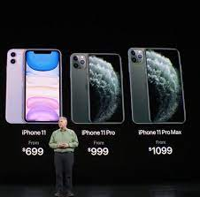

- Penetration Pricing
Penetration pricing is when the prices of a commodity are initially set with the objective of rapidly increasing market shares. Apple Company uses price penetration to attract customers to purchase new commodities by providing lower prices, especially during that particular offer.



- Freemium
It includes offering a free category of the product and then upselling the customers into a paid version. Freemium apps have become the most dominant monetization strategy for many apps. It accounted for 95% of the Apple App Store revenue, 98% of the Google Play Store revenue.

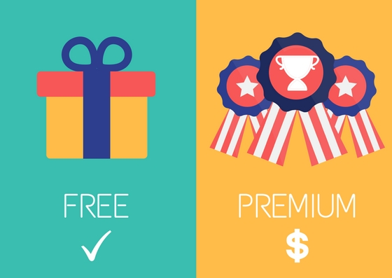

- Price Discrimination
Price discrimination refers to setting different prices for the same commodity in different geographical locations. The Apple Company can maximize price discrimination; for example, a phone plan charges higher prices after determining the number of minutes used.



- 5. Value-Based Pricing
Apple Company makes good use of value-based pricing in their product line-up. Although, Apple is not immune to price resistance when it will go beyond the consumer's expectations. During the first launch of the iPhone, it was roughly $599.

